Task 1:

Product: Study table

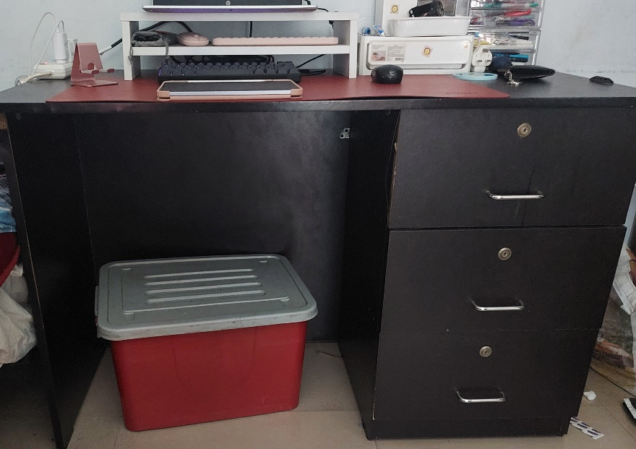

1. Form of Appreciation:

* Size is big enough for me to fit my laptop, notebooks and other stationaries which I need when I am studying
* Drawers with large enough capacity to store all my stationaries and electronics
* Appropriately levelled so that I can sit comfortably and reach the table
* There is large leg-space below the table for comfortable movement and storage
* It is made of plywood and is durable and not damages easily
* It has a deep brown colour which gives a aesthetic look.

1. Designer’s perspective:

* Requirements:
  + large size but still movable and able to be rearranged
  + tall enough so that when sat on chair can reach table comfortable
  + light weight
  + levelled surface
  + all legs of the table should be of same length and table not shaky

|  |  |
| --- | --- |
| **Feature** | **Specifications** |
| Make | Kamatchi Furnitures |
| Size (l x b x h) | 47.5’’ x 24’’ x 31’’ |
| Shape | Rectangular |
| Colour & Finish | Deep brown, matte |
| Number of drawers | 3 |
| Depth of Drawers | 5’’ |
| Weight | 15kg |
| Material | Plywood |
| Thickness of table | 1’’ |

1. Features that delight me:

* Deep drawers: I am able to store a lot of stationaries and accessories
* Large width of table: able to keep my laptop and notebook at same time
* Large leg-space: to store box and move around comfortably

1. Feature that will excite me:

* The table’s height and tilt is changeable
  + If I can change the height of table to suit to my liking
  + I can change into a standing desk when I want to
  + Tilted table is more comfortable for writing
  + The angle of tilt can be changed to make it more comfortable

Task 2:

Product: Extension box

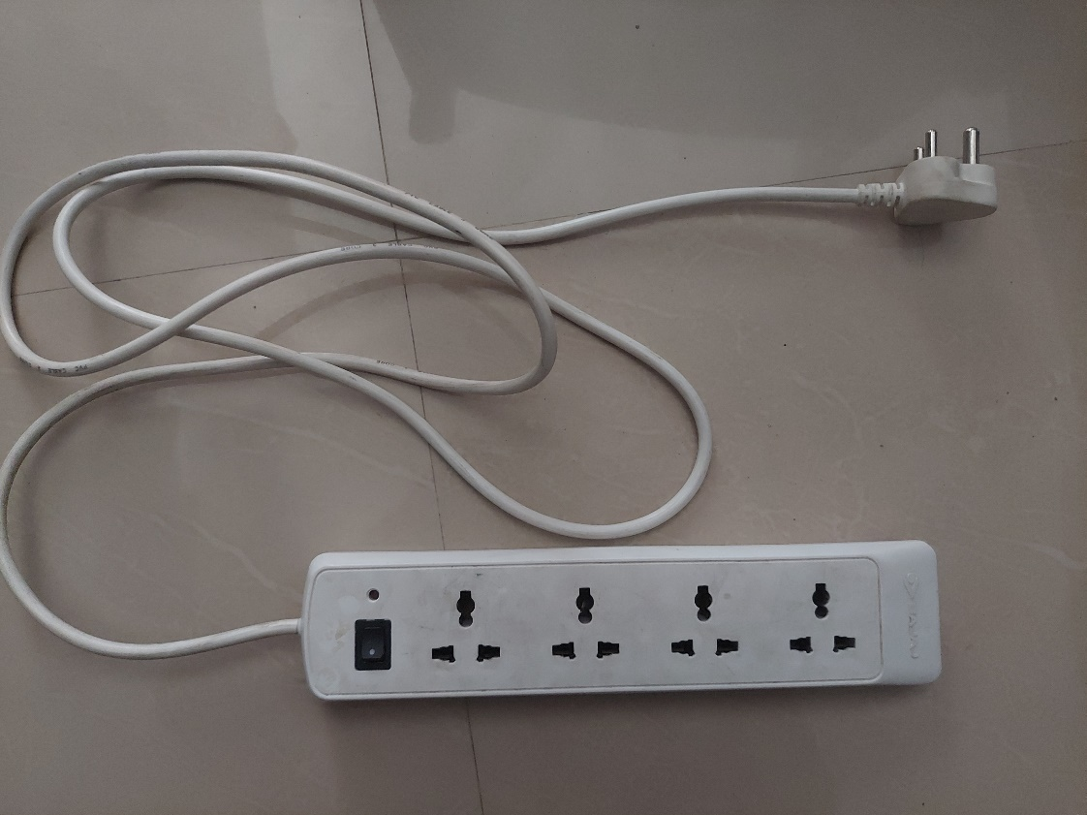

1. Critique on product:

* The product does not have separate switches for each port
* the long cord cannot be stored properly
* the product does not have a surge protector
* product only has 4 ports
* The adjacent ports are too close to each other

1. Requirements:

* Multiple ports
* Light indicator for showing if it is turned on
* Long cord

Specifications

|  |  |
| --- | --- |
| **Feature** | **Specifications** |
| Make | Bajaj |
| Shape | Rectangular box |
| Colour | White |
| Dimensions | 28 x 6 x 2.5 |
| Number of ports | 4 |
| Number of switches | 1 |
| Number of light indicators | 1 |
| Type of ports | Universal |
| Material | Plastic |
| Length of cord | 2m |
| Type of cord | Thick, insulated using rubber |

1. Comparing with other products available in market

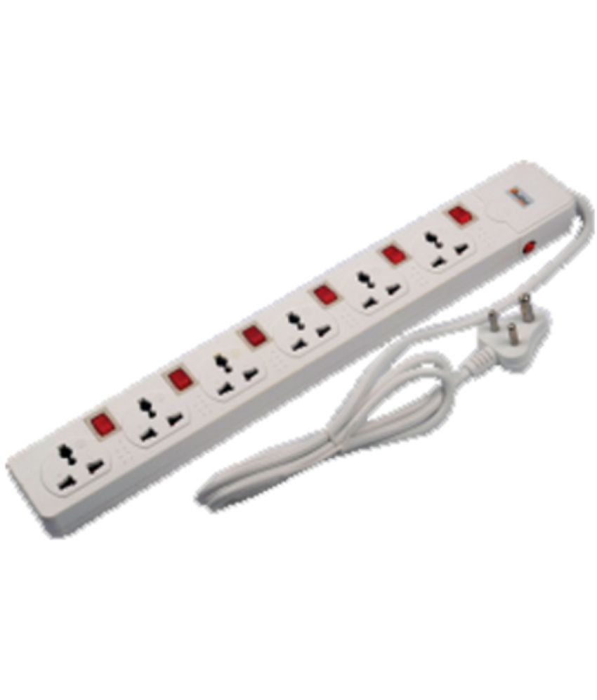

|  |  |
| --- | --- |
| **Feature** | **Specifications** |
| Make | Stackfine |
| Number of sockets | 6 |
| Wire length | 4m |
| On/Off Switch Type | Individual Socket On/Off |
| Cord wrap type | Rubber |
| Typo of sockets | Universal pin |
| Surge protection | Available |
| Colour and shape | White and rectangular box |

Features that were missing:

* More number of sockets
* Individual switches and light indicators
* Longer cord

1. Feature that will delight

* A cord holder which will coil the unused coil and store it without looking messy and tangling the long cord